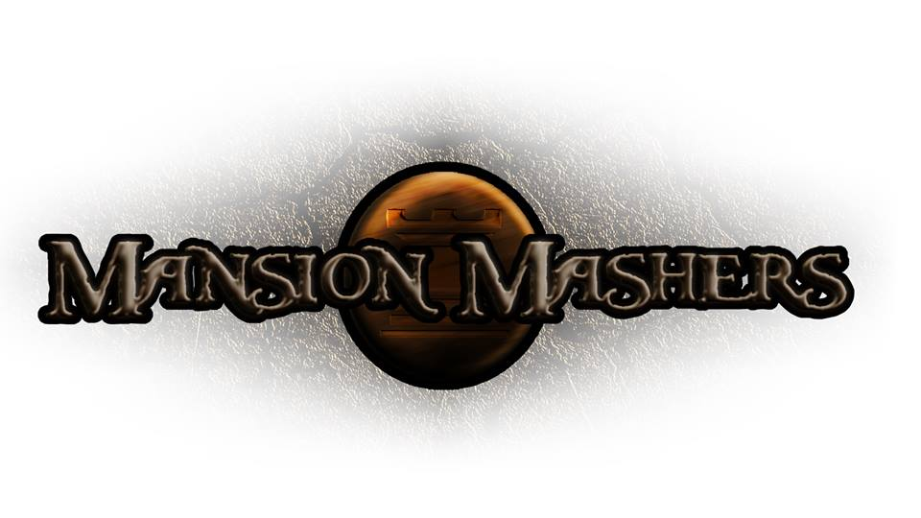**Weekly Production Report**

**Week 12**

**April 3, 2014**

**By Juli Gregg**

**High Concept**:

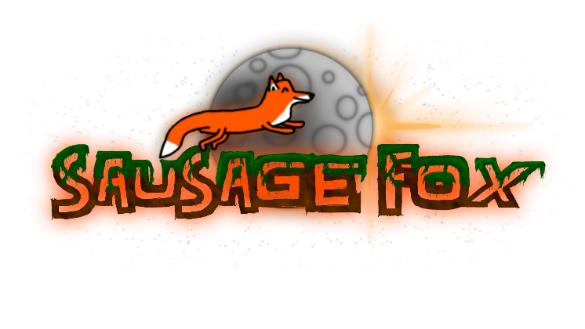A 2-D fast-paced, side scrolling hack and slash game set in a cartoon fantasy world with character ability progression.

**Producer:**

Juli Gregg

**Tech Director**:

Dan Muller

**Game Designer**:

Luke Conlon

**Product Manager**:

Kaden Nugent

Project Status:

Green

Current Milestone:

Beta

Accomplishments:

|  |  |
| --- | --- |
| **Juli Gregg:** | Added sounds, narrative, scrolls with text and glow effects to platforms. Created art for and began to place in buffs. Implemented a Credits page. Made and setup presentation assets. |
| **Dan Muller:** | Implemented an infinite spawner, weapon comparison, enemy counter, and arrow indicators. Fixed weapons overlapping. Updated Options Menu, Main Menu and Map logic. Balanced attacking and did bug fixes. |
| **Luke Conlon:** | Finished first and second boss art and animation. Fixed enemy bugs. Implemented spear animation and new art for wind attack. Updated HUD art and logic (w/cool down bar). Created art for Intel Fox character. |
| **Kaden Nugent:** | Added ranged wind attack for player. Implemented leveling up and experience system. Fixed up tutorial. Added sounds to shop. A lot of bug and memory fixes. |

Objectives:

|  |  |
| --- | --- |
| **Juli Gregg:** | Clean up art and levels. Add in two cut scenes and remaining sounds. |
| **Dan Muller:** | Implement logic for final boss. Bug fixes. |
| **Luke Conlon:** | Polish. Finish up boss art. |
| **Kaden Nugent:** | Add level up reward system and leveling up screen. Make tutorial include buffs. More bug fixes/polish. |

Playtesting Notes

|  |  |
| --- | --- |
| Feedback | Changes Made |
| -Add weapon comparing  -game feels repetitive  -feedback is good could be more  -make map easier to navigate  -enemies move too slow  -controls are easy to grasp | -Weapon stats display +/- compared to current weapon  -Created wind/range attack for player, added buffs  -Added more sounds effects for feedback  -Place you on next level, can double click to enter level  -Balanced enemy attacks, increase each level  -Add keyboard attack buttons in addition to mouse |

Group Accomplishments:

|  |  |
| --- | --- |
| **Weekly Group Meeting** | Discussed what we wanted to present at Beta, the feedback we received from playtesting, and assigned tasks for the week. |
| **Repository**  **Commit Stats** | This week: 87  In a month: 277 |

Group Objectives:

|  |  |
| --- | --- |
| **Weekly Group Meeting** | Discuss polishing goals for the week. Assign finishing tasks. |

Highlights:

Everyone was excited to hear our voices in the game especially the moose sayings in the shop. Also every week everyone is happy they got to talk to Mark Ward.

Risks & Mitigations:

|  |  |
| --- | --- |
| **RISKS:** | (1) A lot of polish needs to be done  (2) Final boss needs to be implemented |
| **MITIGATIONS:** | (1/2) Assigning every one tasks and communicating so that we can finish up the game in the most efficient way possible. |

**Signatures**

_____________________

Juli Gregg

_____________________

Dan Muller

_____________________

Luke Conlon

_____________________

Kaden Nugent